Graham County Sheriff’s Office
Social Networking Policy

- This policy is intended to address issues associated with the use of social networking sites, and provides guidelines for the regulation and balancing of member speech and expression with the needs of the Graham County Sheriff’s Office.

This policy applies to all forms of communications including, but not limited to, film, media, print media, public or private speech and use of all internet services. Including the web, email, file transfer, remote computer access, news services, social networking, social media, instant messaging, blogs, forums, videos and other file sharing sites.

Nothing in this policy is intended to prohibit or infringe upon any communication, speech or expression that is protected or privileged under law. This includes speech and expression protected under state or federal constitutions as well as labor or other applicable laws. For example, this policy does not limit a member from speaking as a private citizen, including acting as an authorized member of an employee group, about matters of public concern, such as misconduct or corruption.

Employees are encouraged to consult with their supervisors regarding any questions arising from the application or potential application of this policy.

- Members of the Sheriff’s Office occupy a trusted position in the community, and thus their statements have the potential to contravene the policies and performance of the Graham County Sheriff’s Office. Due to the nature of the work and influence associated with the law enforcement profession, it is necessary that members of this office be subject to certain reasonable limitations on their speech and expression. To achieve its mission and efficiently provide service to the public, the office will carefully balance the individual member’s rights against the needs and interests of the office when exercising a reasonable degree of control over its member’s speech and expression.

- Members should consider the safety of themselves, family members and fellow employees when using the internet. Speech and expression that can negatively affect the safety of all, include the posting of personal information and photographs in a public forum. This can compromise your address, family ties, where you and fellow officers work.

Pg. 1
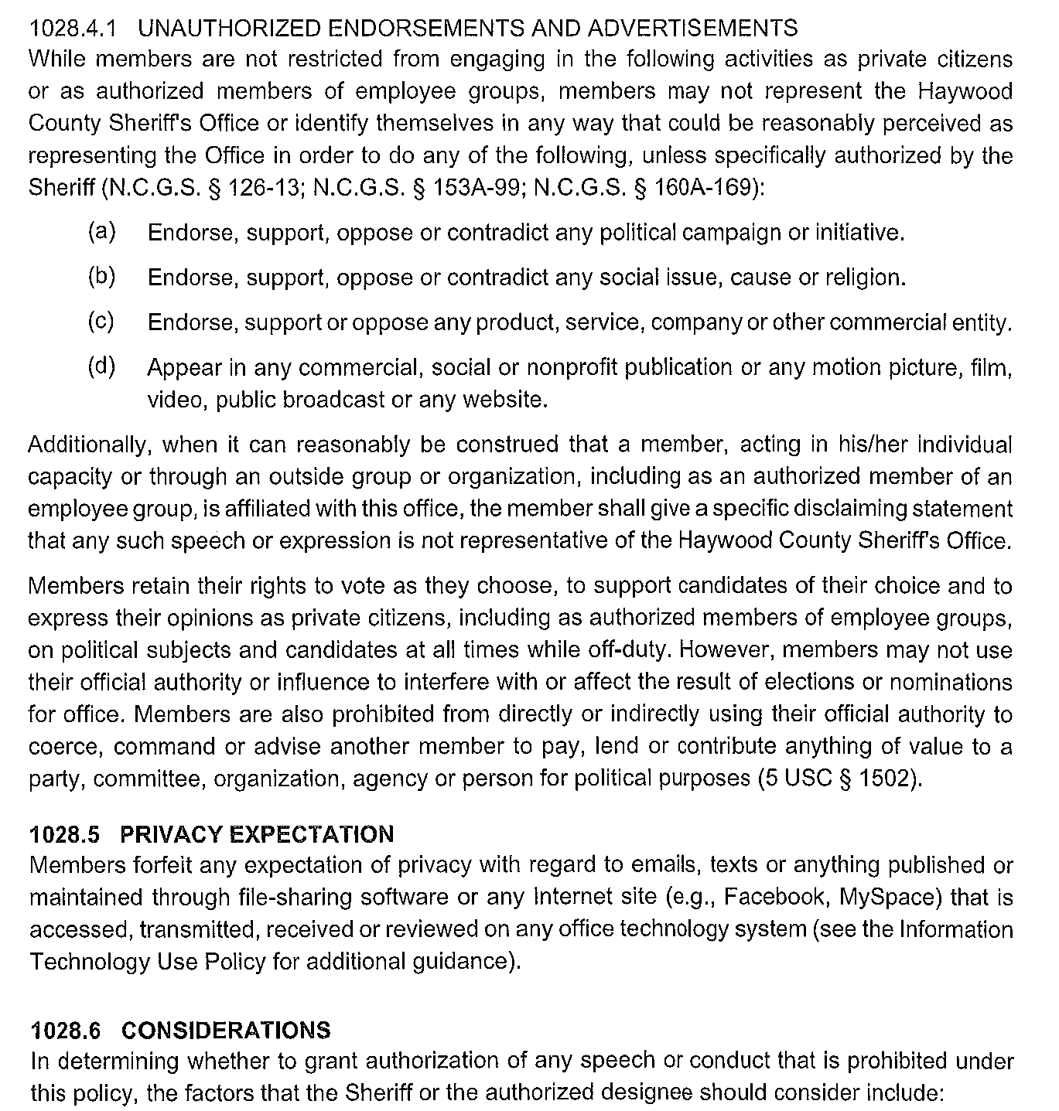
- PROHIBITED SPEECH, EXPRESSION AND CONDUCT
To meet the safety, performance and public trust needs of the Graham County Sheriff’s Office, the following are prohibited unless the speech is otherwise protected 9for example, a member speaking as a private citizen, including acting as an authorized member of the Sheriff’s Office on a matter of public concern):

- Speech or expression made pursuant to an official duty that tends to compromise or damage the mission, function or reputation or professionalism of the Sheriff’s Office or its employees.
- Speech or expression that, while not made pursuant to an official duty or while in an off duty status, is significantly linked to, or related to, or tends to compromise or damage the mission, function, reputation or professionalism of the Sheriff’s Office or its employees. Examples may include:
- Statements that may indicate disregard for the law or the state or the U.S. Constitutions.
- Expressions that demonstrates support for criminal activity.
- Participation in sexually explicit photographs or videos for compensation or distribution.
- Statements that could be construed as bullying or unbecoming of a law enforcement officer.
- Speech or expression that could reasonably be foreseen as having a negative impact on the credibility of the employee as a witness. For example, posting statements or expressions to a website that glorifies or endorses dishonesty, unlawful discrimination or illegal behavior.
- Speech or expression of any form that could reasonably be foreseen as having a negative impact on the safety of the employees of the Sheriff’s Office ( e.g., a statement about a sheriff’s office operation or procedure that could inform criminals of details and therefor placing officers lives in danger.
- Speech or expression that is contrary to the law enforcement Code of Ethics as adopted by this Office.
- Use or disclosure through whatever means, of any information, photograph, video or other recording obtained or accessible as a result of employment or appointment with the Sheriff’s Office for financial or personal gain, or any disclosure of such materials without the express authorization of the Sheriff or his authorized designee.
- Posting, transmitting or disseminating any photographs, video or audio recordings, likenesses or images of office logos, emblems, uniforms, badges, patches, marked vehicles, equipment or other material that specifically identifies the Graham County Sheriff’s Office on any personal or social networking or other website or web page, without the express authorization of the Sheriff.
Pg. 2

Employees must take reasonable and prompt action to remove any content, including content posted by others, that is in violation of this policy from any web page or website maintained by the employee (e.g., social or personal website).

- UNAUTHORIZED ENDORSEMENTS AND ADVERTISEMENTS
While employees are not restricted from engaging in the following activities as private citizens or as authorized employees of employee groups, employees may not represent the Graham County Sheriff’s Office or identify themselves in any way that could be reasonably perceived as representing the office in order to do any of the following, unless specifically authorized by the Sheriff (N.C.G.S 126-13; 153A-99; 160A-169):
- Endorse, support, oppose or contradict any political campaign or initiative.
- Endorse, support, oppose or contradict any social issue, cause or religion.
- Endorse, support or oppose any product, service, company or other commercial entity.
- Appear in any commercial, social or nonprofit publication or any motion picture, film, video, public broadcast or any website.
Additionally, when it can be reasonably be construed that an employee, acting in his/her individual capacity or through an outside group, is affiliated with this office, the member shall give a specific disclaiming statement that any such speech or expression is not representative of the Graham County Sheriff’s Office.
Employees retain their rights to vote as they choose, to support candidates of their choice and to express their opinions as private citizens, including as authorized members of employee groups, on political subjects and candidates at all times while off duty. However employees may not use their official authority or influence to interfere with or affect the result of elections or nominations for office. Employees are also prohibited from directly or indirectly using their official authority to coerce, command or advise another employee to pay, lend or contribute anything of value to a party, committee, organization, agency or person for political purposes (5 USC 1502).

Pg. 3
- PRIVACY EXPECTATION
Employees forfeit any expectation of privacy with regard to emails, texts or anything published or maintained through file-sharing software or any internet site (e.g., Facebook, TikToc, Instagram, Snapchat) that is accessed, transmitted, received or reviewed on any Sheriff’s Office Technology System.
- CONSIDERATIONS
In determining whether to grant authorization of any speech or conduct that is prohibited under this policy, the factors that the Sheriff or his authorized designee should consider include:
- Whether the speech or conduct would negatively affect the efficiency of delivering public services.
- Whether the speech or conduct would be contrary to the good order and discipline of the Office or the efficiency or morale of its members.
- Whether the speech or conduct would reflect unfavorably upon the Office.
- Whether similar speech or conduct has been previously authorized.
- Whether the speech or conduct may be protected and outweighs any interest of the Office

- TRAINING
Subject to available resources, the office should provide training regarding the limitations on speech, expression and use of social networking to all employees of the office.

Pg. 4

